Indian Express Webpage

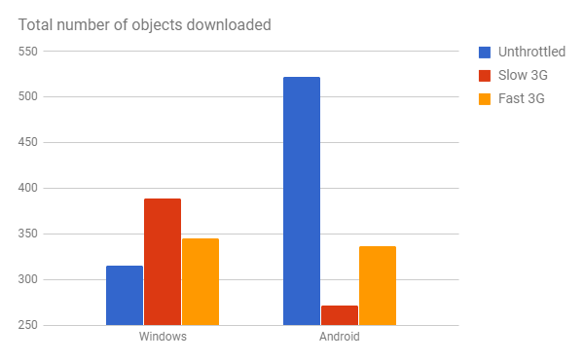

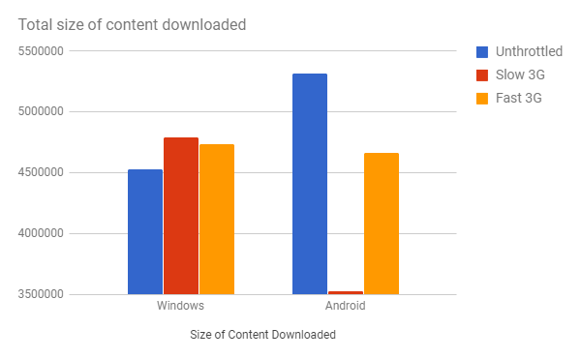

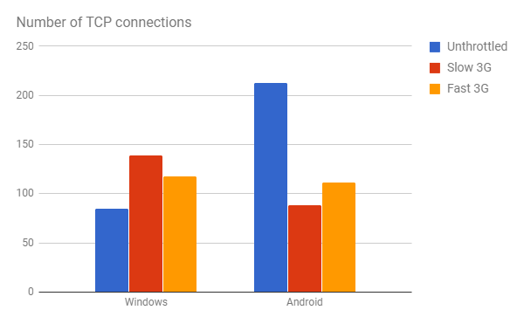

1. Number of TCP connections opened by desktop browser is **more** than mobile except for unthrottled profile.
2. Number of TCP connections opened in Slow 3G and Fast 3G are almost **equal**.
3. A cap is imposed by browser on number of objects downloaded per TCP connection to at most 20.

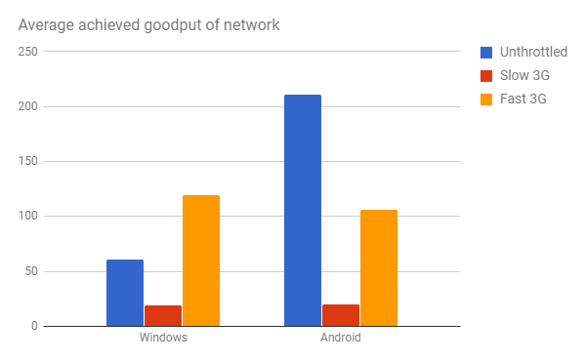

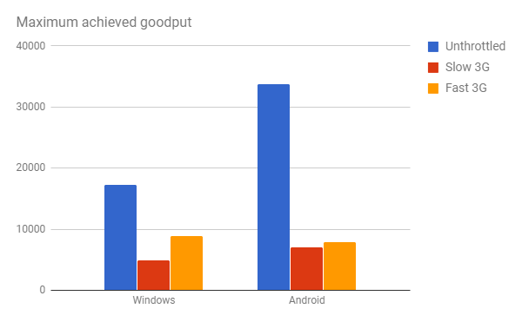

The **download capacity** was not utilized well to access the web pages since the average goodput of network is significantly less than maximum of the maximum achieved goodput across all connections.

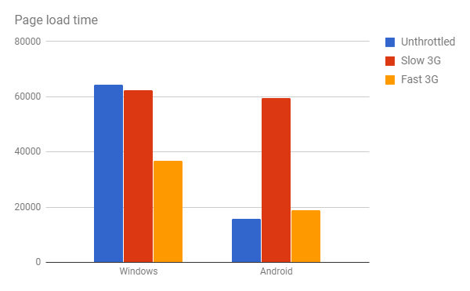

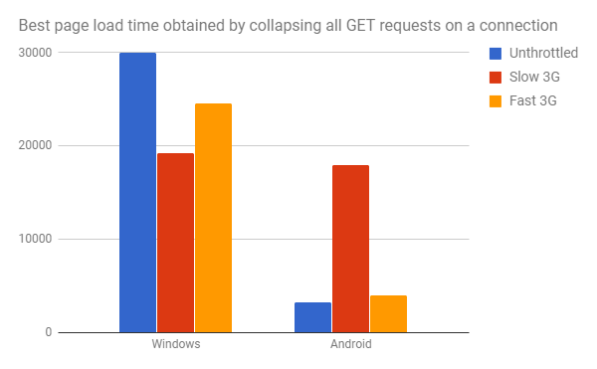

The page load time obtained by collapsing all GET requests on each TCP connection, so that the objects are received back to back and there are no idle times is **significantly less** than actual page load time. This takes less time because we consider maximum over all waiting times for objects downloaded on each connection rather than adding them up.

We also ran another calculation assuming that all content from a domain can be downloaded on a single TCP connection at the maximum achieved goodput seen for that domain. This page load time calculation was also less than actual value.